CS570 – Software Testing

**HOP06A – Selenium WebDriver – Handling Keyboard & Mouse Events**

11/07/2020 Developed by Kim Nguyen

Center for Information Assurance (CIAE) @City University of Seattle (CityU)

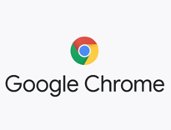

**Caution**

* If you already finished this module through any CityU School of Technology & Computing (STC) courses, just skim this module and skip it.
* Some version numbers may not match with the newly released ones. If so, stay with the most recent ones.
* This tutorial targets Windows OS and Mac users.
* We cannot explain every step. This cookbook always needs your own creative judgement. Try to solve the problem on your own, after a few tries, if you cannot solve the issue, contact TA for help.

**Learning Outcomes**

* Deeper understanding of Selenium WebDriver.
* Continue performing web app testing using script, specifically able to:
  + Handling different Keyboard & Mouse Events

**Resources**

* Javapoint.come | Selenium WebDriver - <https://www.javatpoint.com/selenium-webdriver>
* Guru-99 | Selenium tutorial - <https://www.guru99.com/selenium-tutorial.html>

When testing software and applications, one of the significant tests to consider is keyboard and mouse events - two most important input devices.

Handling special keyboard and mouse events are done using the Advanced User Interactions API. It contains the Actions and the Action classes that are needed when executing these events. Action includes various operations such as multiple events clicking by control key, drag and drop events and many more

The following are the most commonly used keyboard and mouse events provided by the Actions class.

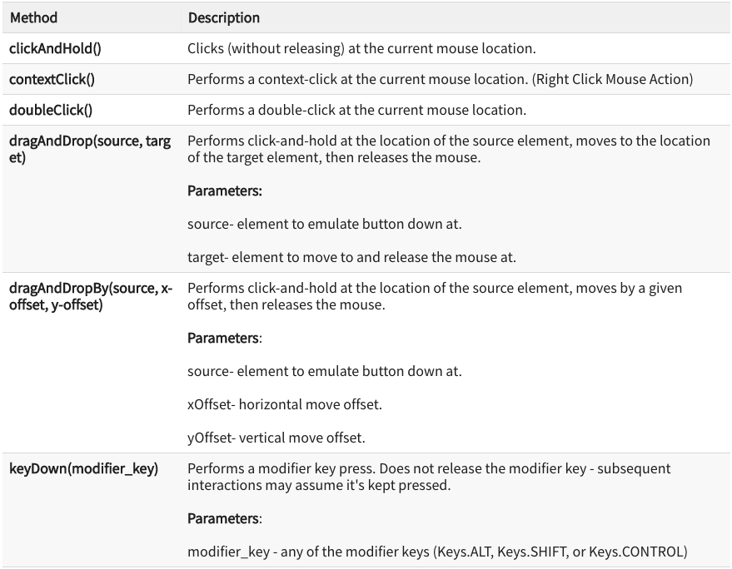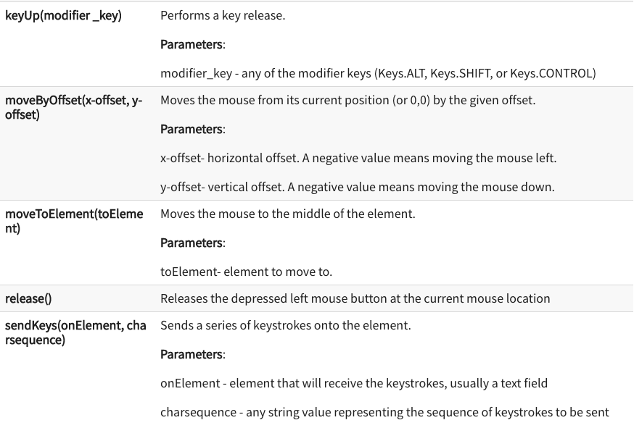

1. Move startUsingSeleniumWebDriver project we created last week to Module 6 folder.
2. In VSCode, open startUsingSeleniumWebDriver folder under the Hands-on Practice folder, the path should be similar to:

CS570-hop-Hands-on-practice/Module6/startUsingSeleniumWebDriver

**Mouse and Keyboard Events**

1. Ope this URL, let’s investigate the website before we write our script: <https://testpages.herokuapp.com/styled/events/javascript-events.html>

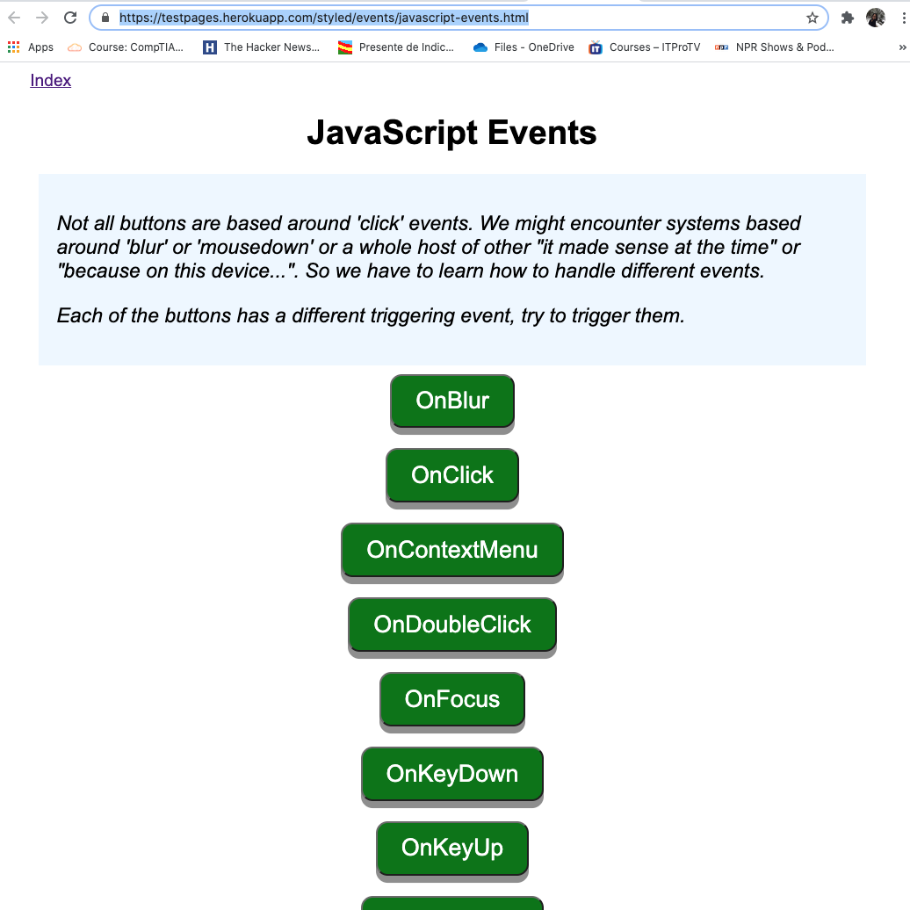

1. Try to click different buttons to see what each button does.
2. Under webdriver folder, create a new file called “MouseAndKeyboard.java”

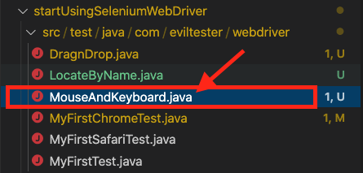

1. Type the following into your MouseAndKeyboard.java:

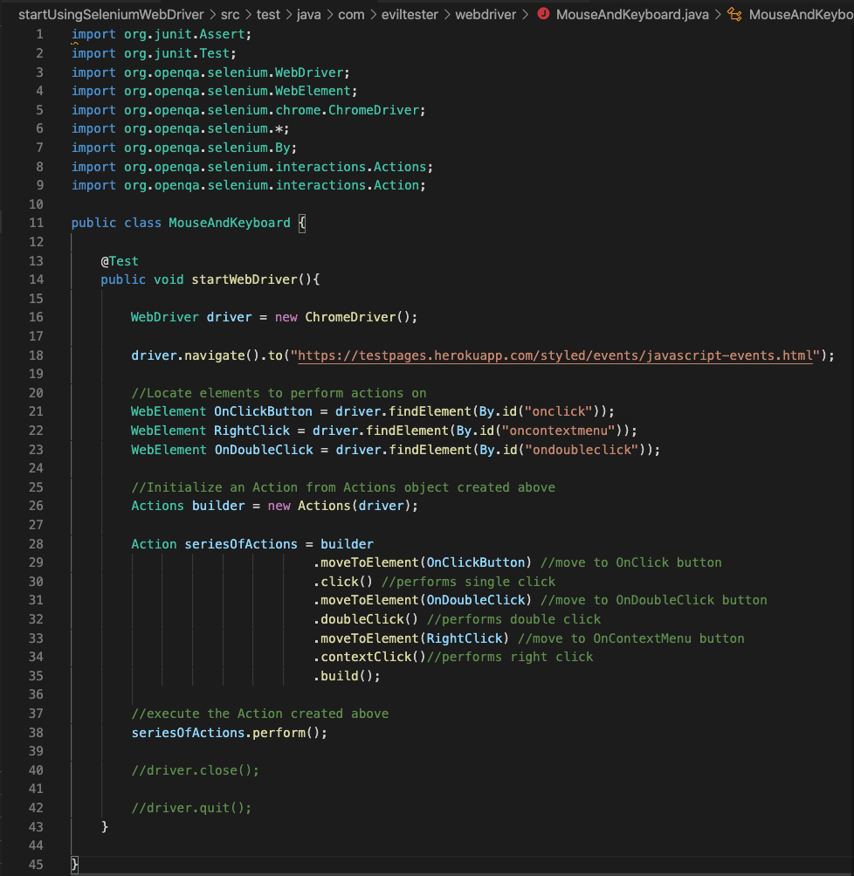

Line 21 to 23: to find the Element ID, right click on the website, click “Inspect” (for Mac Users) or “View Page Source” (for Windows Users), select element you want to inspect to see the detail:

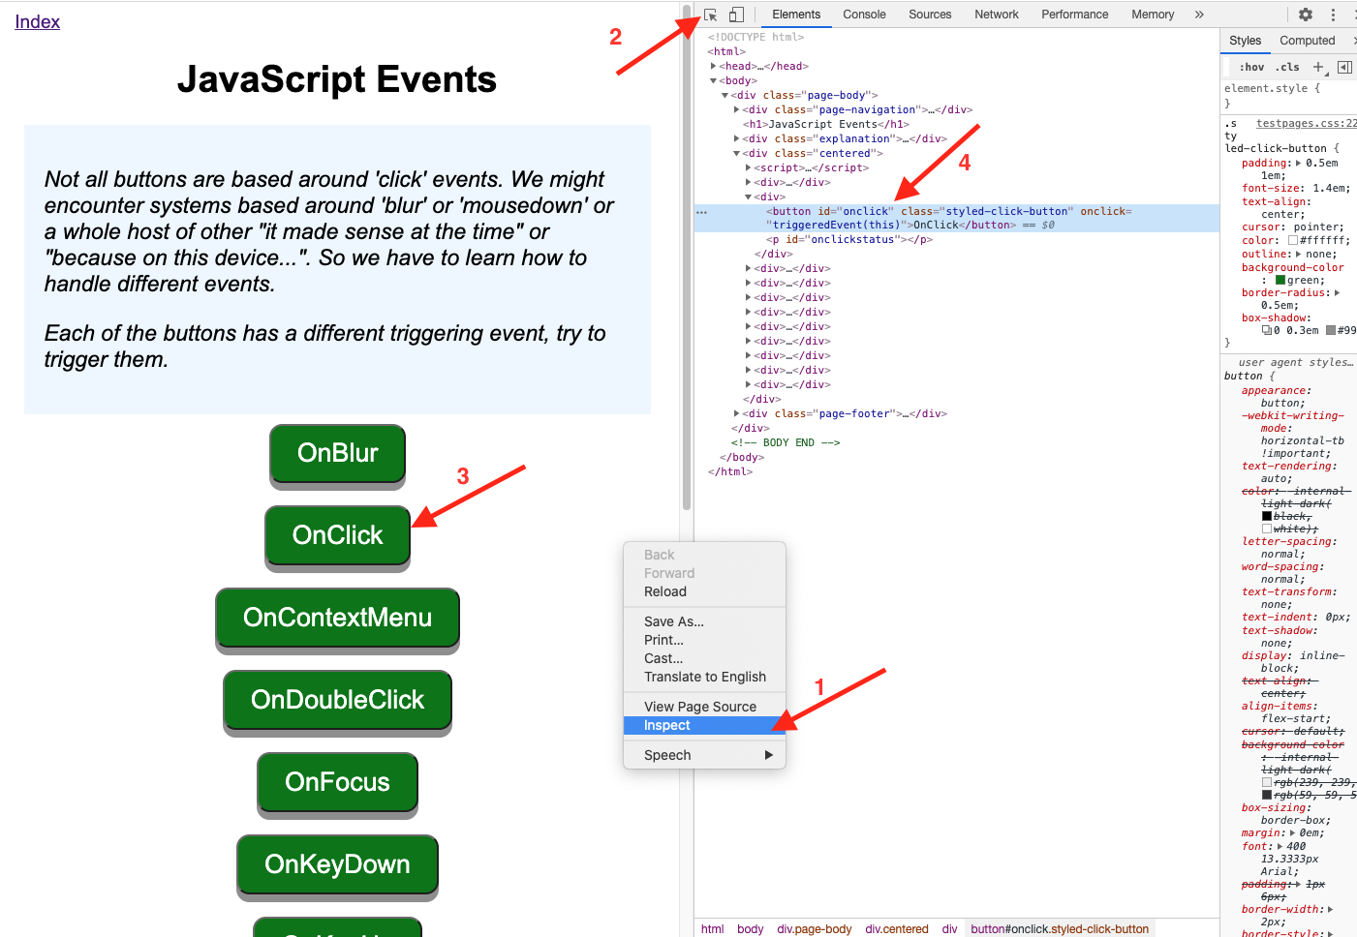

1. Run the test to see result, using the following command:

mvn test -Dtest= MouseAndKeyboard.java

(Make sure you are in the right path when running the command. You should be in the startUsingSeleniumWebDriver folder path)

You should see 3 buttons were clicked as expected:

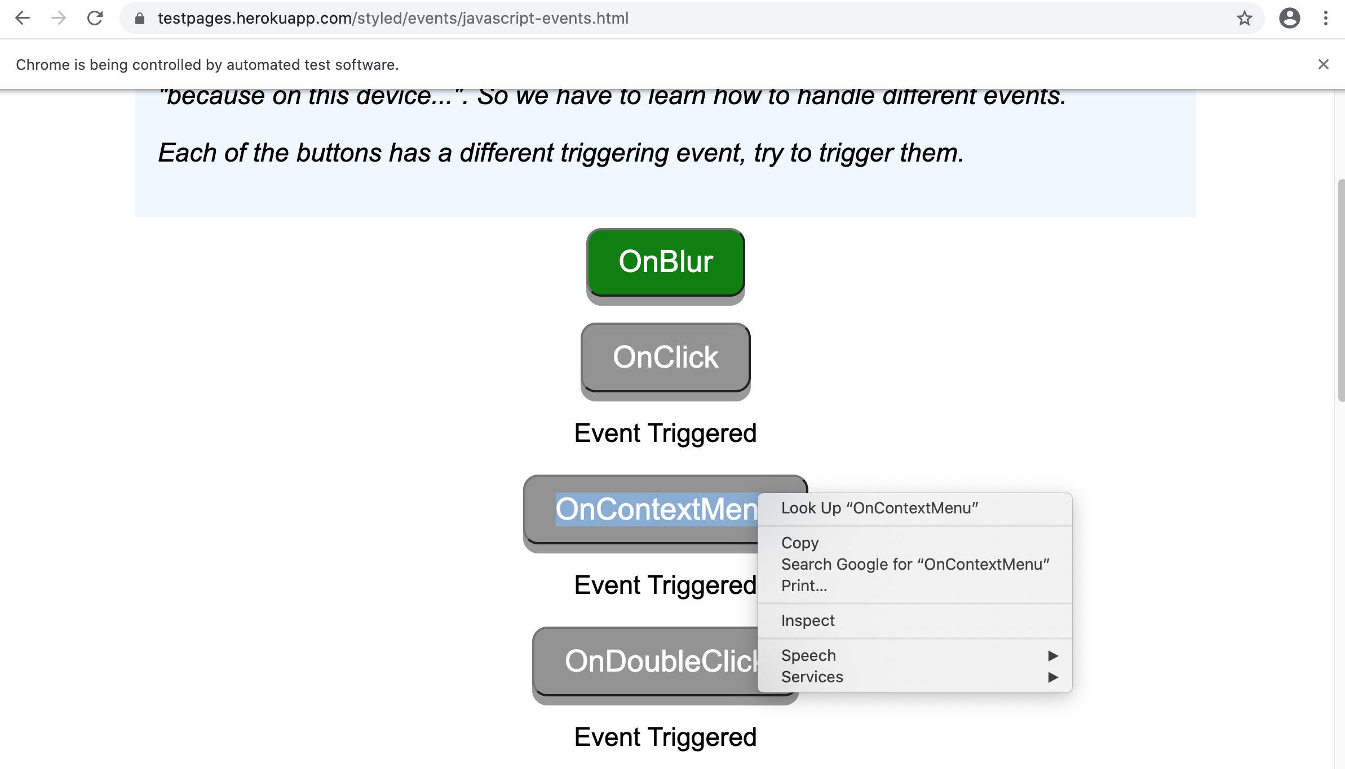

**Challenge:**

Write a script to perform a test on the OnKeyPress button:

Hint: This button can be triggered by pressing any key on the keyboard.

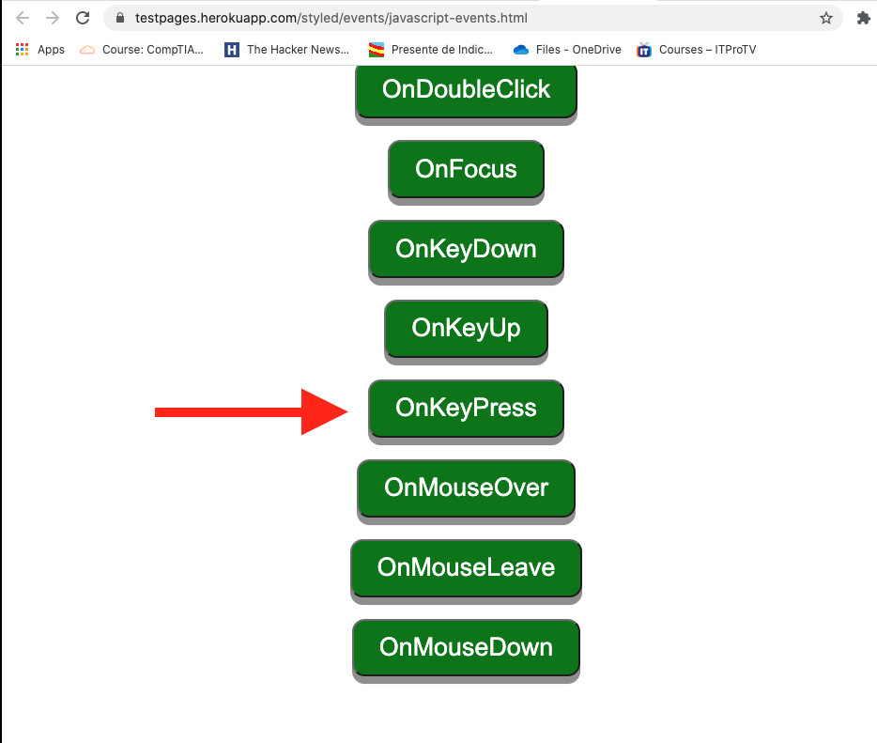

**Once you have completed all tasks in this document, move on to HOP06B – Selenium WebDriver – Drag and Drop Actions document.**

**Error:**



**Solution:**

**Result:**

